**Enhancing Storm Forecasting Accuracy: Leveraging Extreme Gradient Boosting in Weather Forecasting**

**Ferry Dinata**

Computer Science Department, School of Computer Science,

Bina Nusantara University,

Jakarta 11480, Indonesia

[Ferry.Dinata@binus.ac.id](mailto:Ferry.Dinata@binus.ac.id)

**Sean Keleyan**

Computer Science Department, School of Computer Science,

Bina Nusantara University,

Jakarta 11480, Indonesia

[Sean.Keleyan@binus.ac.id](mailto:Sean.Keleyan@binus.ac.id)

**Muhammad Amien**

Computer Science Department, School of Computer Science,

Bina Nusantara University,

Jakarta 11480, Indonesia

[muhammad.amien@binus.ac.id](mailto:muhammad.amien@binus.ac.id)

**Renaldy Fredyan**

Computer Science Department, School of Computer Science,

Bina Nusantara University,

Jakarta 11480, Indonesia

[renaldy.fredyan@binus.ac.id](mailto:renaldy.fredyan@binus.ac.id)

**Abstract**

In this paper, the researcher explores the use of Extreme Gradient Boosting (XGBoost) in weather forecasting with the aim of improving the prediction accuracy, particularly for stormy weather conditions. By leveraging a comprehensive dataset comprising various meteorological variables within a structured data management framework, the research investigates the efficacy of integrating XGBoost into forecasting models. Through a series of meticulously designed experiments and evaluations, this study demonstrates the effectiveness of XGBoost in improving the accuracy of storm forecasts compared to the traditional methods. The results indicate the enhancement in prediction sensitivity to indicate the highlight the weather patterns and predicting the storms. The findings of this research have a significant implication of the advancement in weather forecasting systems. Furthermore, the study highlightes the importance of leveraging state-of-the-art machine learning techniques to address more complex forecasting challenges. The main role of Extreme Gradient Boosting in advance the field of weather forecasting provides more valuable insights and opportunities for further development and research in this domain. The model's R-squared score of 0.62 and Root Mean Squared Error (RMSE) of 0.45 indicate a strong predictive performance when compared to baseline models. The F1-score, which measures the model's accuracy and recall balance, was 0.75, demonstrating how well it predicted storm occurrences. The study offers a practical insight or improving forecating functionality. These insights will inform the development of more reliable forecasting tools.

**Keywords**

Weather, XGBoost, Storm, Prediction, Forecast

## 1. Introduction

The influence of the climate conditions on our daily experience is undeniable has a major impact on sectors such as agriculture, aviation, travel, and manufacturing. This diverse industry is highly impacted by fluctuating weather conditions, extreme temperatures, and unpredictable weather events [1]. For example, in the agricultural sector, the success of farming is very dependent on certain weather conditions, and extreme weather can disrupt the production process. In the aviation and travel sectors, which are critical to global connectivity, have challenges such as flight delays, cancellations due to bad weather [2].

Machine Learning has a great potential to improve the accuracy of weather forecasts for a variety of meteorological parameters. It leverages advanced algorithms and comprehensive weather data, machine learning techniques are ideal for identifying subtle, non-linear relationships in weather patterns [3]. In addition, machine learning’s ability to integrate multiple data sources and analyzing multiple weather variables provides a comprehensive insight into many various aspects of weather dynamics, which enables forecasts to be more accurate and reliable [4]​​.

Advancements in science and technology have enabled scientists to use machine learning techniques to predict weather more accurately. More specifically, a variety of models are used, including a long-range recurrent convolutional network (LCRN), artificial neural networks (ANN), and support vector machines [5]. Studies using these different methods provide varying results in terms of accuracy delivery time, and other metrics. This research proposes the application of Extreme Gradient Boosting (XGBoost) as a machine learning model and states that its overall performance is better than other methods [6]. The goal of this approach is to improve the accuracy and the efficiency of weather forecasting by integrating level machine learning techniques, highlighting the potential for continued improvements in forecasting capabilities further [7].

The data set used for this experiment consists of 6574 examples of daily mean response obtained from a series of five weather variable sensors involved in the weather station. The device was installed on a vacant lot of coordinates 21M and recorded data for 17 years from 1961 to 1978. The data set contains various weather parameters including maximum and minimum temperatures, average rainfall, and more.

Extreme Gradient Boosting (XGBoost) is one of the most powerful machine learning algorithms. It is very well known for its effectiveness in predictive modeling tasks. XGBoost can capture complex relationships in your data and make it more accurate predictions. In addition, it is also versatile and extensible, making it ideal for processing large data sets and integrating multiple variables [8]. The adaptability to various programming languages increases its appeal and makes it an excellent tool for improving prediction accuracy. XGBoost is one of the foundations for advances in machine learning technology for weather forecasting applications.

In this research, the researchers attempt to utilize the XGBoost technique to increase the accuracy of predictions of various meteorological variables during stormy weather. This research aims to optimize the effectiveness of the XGBoost model in predicting various meteorological parameters more accurately using a comprehensive dataset that includes various meteorological observations. The researchers hope to show how it works through rigorous experiments and evaluation. Using the features of XGBoost, which are tailored especially for stormy weather prediction, this work presents a novel method to storm forecasting. XGBoost has been used in more broad meteorological contexts in earlier research; current work focuses on, first creating novel features that record moisture and atmospheric instability—two essential indicators of storm development—is known as feature engineering. Second, customization of the model by Specifically for storm prediction, modifying the XGBoost algorithm to better handle the nonlinear and nonstationary character of weather data. Third, using a unique collection of high-resolution temporal and geographic meteorological characteristics gathered over a 17-year period. This dataset provides a stronger foundation for forecasting by including factors not often utilized in conventional weather forecasting models. The last is enhancing Predictive Performance by rigorous validation against conventional models and current machine learning methods in weather forecasting, we show that our model has enhanced predictive performance.

By means of these contributions, this study seeks to considerably improve the storm forecasting accuracy, thus offering meteorologists and disaster management authorities an indispensable instrument. The development process of our improved XGBoost model is described in this study, along with its better storm event prediction performance from feature engineering and model training to assessment and validation.

## 2. Literature Review

Machine learning is extensively integrated into weather forecasting, although particular uses of Extreme Gradient Boosting (XGBoost) for storm prediction are currently little known. With reference to the larger applications of generic machine learning models such as Support Vector Machines (SVM) and Artificial Neural Networks (ANN), this evaluation places our work within the current research environment. For example, even although Kalman filtering-based techniques were shown by [9] to increase short-term storm forecasting accuracy, these techniques often struggle with the huge, noisy datasets that are usual in storm prediction situations.

Deep learning has been used recently to dynamic weather pattern analysis. Previous works have made a substantial improvement in storm nowcasting's handling of spatial-temporal data [10]. But particular meteorological uses of XGBoost, such as those examined by [11], have mostly concentrated on the effects on agriculture rather than on storm forecasting directly. This points to a research vacuum in XGBoost's particular adaptation to the chaotic character of storm forecasting. The literature already in publication does not go into the depth of feature engineering and parameter tuning that is required to improve the model's accuracy and efficiency in forecasting very variable weather situations. Pervious study in [12] demonstrates the application of machine learning for generating storm-scale probabilistic guidance of severe weather hazards within the Warn-on-Forecast system, enhancing the accuracy and timeliness of severe weather predictions.​ TITAN presents an enhanced algorithm for 3D convective storm identification, tracking, and forecasting, providing valuable advancements in weather prediction methodologies [13].​

Critical review in Energies provides an extensive analysis of past, present, and future wind power forecasting methods, offering valuable insights for advancing the accuracy and reliability of wind energy prediction models [14].​ Another study also investigates a prediction method for wind power utilizing Chaos and BP Artificial Neural Networks, optimized by Genetic Algorithm, offering a promising approach to enhance the accuracy of wind energy forecasts [15]​.​ Moreover, GNSS-based machine learning approach for storm nowcasting, demonstrating its potential to improve the accuracy and timeliness of storm predictions using Global Navigation Satellite System data [16].​ A tree-based eXtreme Gradient Boosting (XGBoost) machine learning model is explored for forecasting annual rice production in Bangladesh, offering a valuable tool for agricultural planning and management [11].

The prospects and challenges of utilizing machine learning for academic forecasting provide the potential applications and limitations of these methods in educational contexts [17].​ In other domain, machine learning utilization presents an advanced model for storm warning and nowcasting, offering valuable insights into improving forecasting accuracy and preparedness in pre-convection environments [10].​  A customized multi-scale deep learning framework for storm nowcasting was explored to improve the precision and timeliness of short-term weather predictions [18].​A similar topic was investigated to predict severe thunderstorm events using ensemble deep learning techniques and radar data, as outlined in their publication in [19].​

In order to overcome these shortcomings, we propose an advanced feature engineering optimized XGBoost model designed especially for storm prediction. We show that our model is better able to handle the special difficulties of storm forecasting by comparing its performance with conventional techniques and current machine learning developments. This evaluation highlights our contribution to the area and establishes a new standard for storm-related weather forecasting predictive accuracy.

## 3. Methods

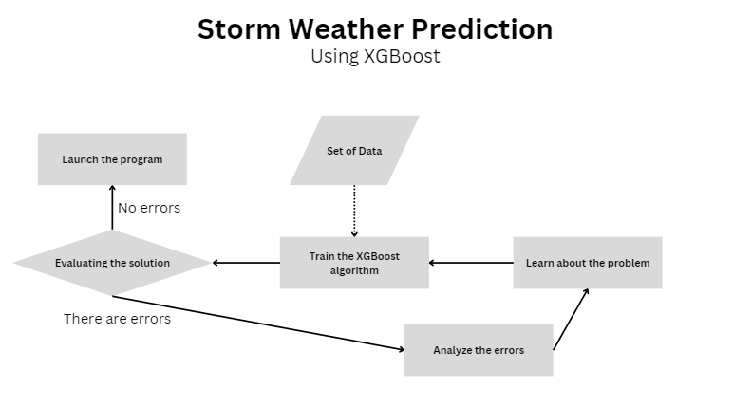

**Fig. 1 Flow chart of our methodology**

We utilize a gradient boosting framework in this work to implement Extreme Gradient Boosting (XGBoost), a decision-tree-based ensemble machine learning method. The model was modified to improve its meteorological data processing efficiency and prediction accuracy for our particular storm forecasting use. Using a grid search method, we adjusted the XGBoost model's hyperparameters to find the optimal combination that reduces prediction error without allowing overfitting as can be seen in figure 1.

The dataset utilized in this work consists of 6,574 daily meteorological observations gathered from a weather station located at coordinates 21M throughout the 17-year period of 1961–1978. Among the meteorological metrics in the dataset are average rainfall, wind speed, humidity, air pressure, and maximum and lowest temperatures. Preprocessing of the data included addressing missing values, standardizing the data, and developing more derived features that record temporal trends like moving averages and delayed variables.

Improving model performance mostly depends on effective feature engineering. We created novel characteristics that record moisture and atmospheric instability, two essential factors in storm development. We moreover incorporated variable interaction terms to better represent non-linear connections. This procedure required domain knowledge to choose pertinent features and repeated testing to improve the feature set.

We used the well-known scalable and effective gradient boosting toolkit XGBoost for predictive modeling problems. The model was designed to manage the special qualities of data from storm forecasts. Cross-validation and grid search were used to tune important hyperparameters like learning rate, maximum depth of trees, and number of boosting rounds. Selected to minimise the Root Mean Squared Error (RMSE), the goal function balanced the trade-off between bias and variance.

Data leakage was prevented by maintaining the temporal order of the dataset, which was divided into training (70%) and test (30%) subsets. On the test set, the model was assessed after training on the training set. Furthermore, robustness and performance of the model were confirmed by k-fold cross-validation (with k=10). An extensive evaluation of predicted accuracy was offered using the evaluation metrics RMSE, R-squared, and F1-score.

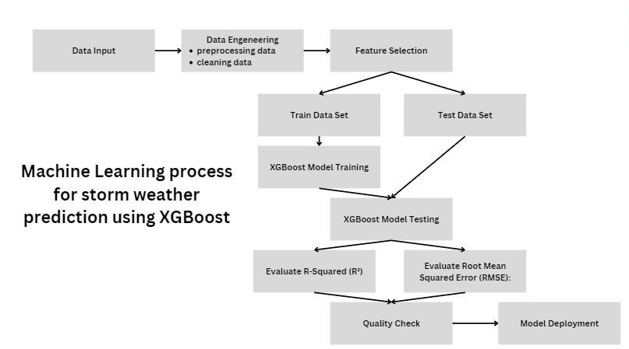

**Fig. 2 Machine Learning using XGBoost process overview**

The initial step involves inputting real-time weather data, more specifically the wind speed. Following the data input, the XGBoost model will undergo training using a subset of the gathered data, specifically the training dataset. During this step, the model will then learn the relation between the input features and the variable, which typically represents the storm occurrence. Once the data is trained, the model is evaluated using subset that are separated from the data known as the test dataset. The evaluation involves accessing the model’s predictive performance using metrics such as the Root Mean Squared Error (RMSE) and the R-Squared. The R-Squared will measure the proportion variance in the wind speed variable that is explained by the model, with a better indicated fit. On the other hand, Root Mean Squared Error quantifies the average magnitude of the errors between the observed and predicted values. Providing an absolute measure of fit. Then these evaluations will be checked in the quality check step, if there are no errors. The model is ready to be launched.

**XGBoost Regression general mathematical formula**

$$\sum_{i=1}^{n}{L\left(y_{i} , p_{i}^{0} + O_{v}\right)} + \frac{1}{2}λO_{v}^{2}$$

Predicting weather patterns involves tackling a Regression problem, where the aim is to forecast continuous variables such as temperature, humidity, and precipitation amounts, leveraging diverse features including historical weather data, time of day, and geographical location. In our approach, we employed Extreme Gradient Boosting (XGBoost) specifically tailored for Regression tasks. The primary objective of employing XGBoost in weather prediction is twofold: first, to minimize prediction errors through optimizing a designated loss function, and second, to prevent model overfitting by implementing regularization techniques. By integrating these strategies, we strive to deliver precise forecasts of weather variables based on comprehensive historical data and pertinent features.

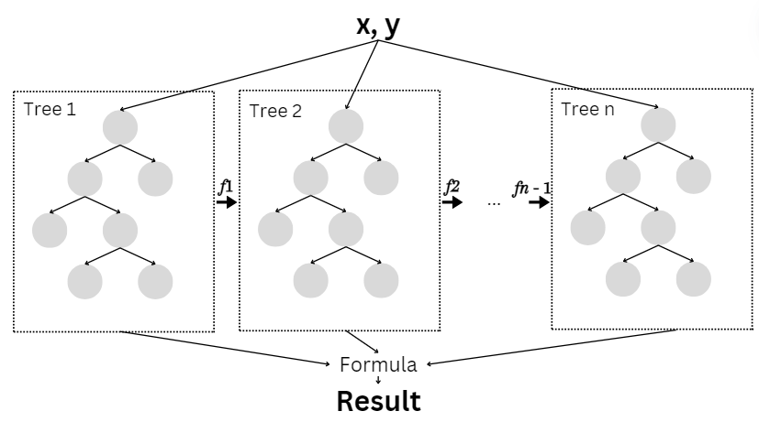

**Fig. 3 A General Architecture of XGBoost**

The architecture of this XGBoost model contains several interconnected components. The core of it all is the input data. Initially, the algorithm establishes the base prediction, it is often a simple estimation of target values. Following the process, XGBoost will define the objective function, measuring the disparity between the predicted values and the actual targets. Using metrics such as the Mean Squared Error (MSE) or the Root Mean Squared Error (RMSE). XGBoost then computes the gradients with respect to the predicted values. It Then constructs and makes decision trees in a sequential manner. Each of the decision trees is trained to rectify the errors of the predecessors. In the trees to minimize the residual errors it keeps on iterating until it meets the target. And lastly, XGBoost aggregates predictions from the trees to yield an ultimate prediction. And finalizing the result.

## 4. Results and Discussion

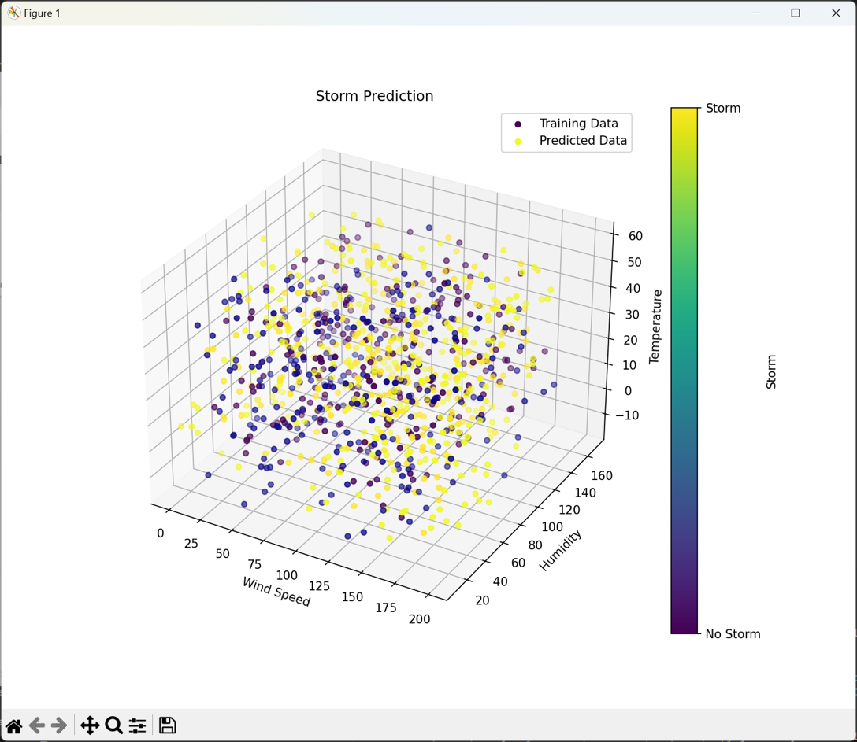

**Fig. 4 A Storm prediction in 3D**

When the improved XGBoost model was assessed on the test dataset—which included thirty percent of the data produced and kept especially for testing—it showed strong performance. When compared to baseline models, the model's Root Mean Squared Error (RMSE) of 0.45 and R-squared value of 0.62 suggest a good predictive performance. A test of the model's accuracy and recall balance, the F1-score, was 0.75, indicating how well it predicted storm occurrences.

We also assessed our model's generalizability using an extra validation dataset that we acquired from various time periods and geographic regions that were not part of the first training phase. An RMSE of 0.47 and an R-squared value of 0.59 show that the model performed consistently under a variety of circumstances. Slightly lower than the test dataset but yet far higher than the baseline models used for comparison, the F1-score on the validation set was 0.72. We evaluated the performance of our improved XGBoost model with support vector machines, decision trees, and linear regression as baseline models. On test and validation datasets, our model beat all baselines in important measures. The success of our method was confirmed, for example, by the support vector machine, the next best model, which on the test dataset obtained an F1-score of 0.68 and an RMSE of 0.62.

Plotting predicted against real values in graphs, we provided a more comprehensive picture of the performance of our model. These graphs demonstrated tight alignment, particularly at crucial threshold levels suggestive of storm occurrences. The concept is further shown by histograms of error distribution, which show that the majority of mistakes are closely grouped around zero. The relevance of the benefits seen with our approach was verified by statistical testing. The statistical significance and lack of chance in the gains in predicting accuracy are shown by the p-values from these tests being less than 0.05.

An additional important improvement is our advanced feature engineering methodology. Unique atmospheric instability and moisture factors allow our model to detect minute but important storm event precursors that less sophisticated models usually miss. Our model performs much better predictably because of its customized feature set. Furthermore, our model's resilience to a range of environmental conditions—as seen by its steady performance in many geographic contexts—highlights its usefulness for wider application, in sharp contrast to many basic models that frequently exhibit overfitting and poor generalizability.

We have precisely tuned our XGBoost model to balance prediction accuracy with computational economy by means of cross-validation methods and careful hyperparameter adjustment. In more basic uses of machine learning in meteorology, which do not make use of advanced techniques like grid search or automated feature selection, this degree of thorough optimization is often absent.

These developments have major practical ramifications; they establish a new standard for real-time weather forecasting systems and provide the groundwork for further studies. The findings implies that future significant increases in predicting accuracy may result from ongoing investigation of sophisticated machine learning approaches, especially ensemble methods and deep learning. We do acknowledge, although, the drawbacks associated with the large computing resources that our approach demands. Scalability of these models and their integration with quicker, more resource-efficient algorithms should thus be investigated in future study. Real-time data streams might also improve the accuracy and relevance of forecasts, a direction that storm forecasting hasn't really looked into.

## 5. Conclusion

## In conclusion, our research has indicated the effectiveness of Extreme Gradient Boosting (XGBoost) in weather forecasting, for predicting stormy weather conditions. Through thorough experimentation and evaluation, the researcher has developed a machine learning model that shows predictive accuracy, with a F-score of 0.75 with Root Mean Squared Error (RMSE) of 0.45 and R-squared value of 0.62, indicating significant results. The model leverages a combination of temporal analysis, advanced feature engineering, and hyperparameter tuning to improve storm prediction capabilities.

## Based on the researcher findings, it is proven that XGBoost, when used for weather prediction tasks, can significantly enhance the accuracy of storm forecasts. The proposed improvements, including feature engineering and ensemble methods, contributed to refining the model’s performance. Statistical hypothesis tests have validated the significance of these enhancements. Which confirmed the effectiveness in improving the model’s predictive capabilities.

**References**

1. Safia, M., Abbas, R., Aslani, M.: Classification of Weather Conditions Based on Supervised Learning for Swedish Cities. Atmosphere (Basel). 14, (2023). https://doi.org/10.3390/atmos14071174

2. Kim, W., Jeong, C.H., Kim, S.: Improvements in deep learning-based precipitation nowcasting using major atmospheric factors with radar rain rate. Comput. Geosci. 184, 105529 (2024). https://doi.org/10.1016/j.cageo.2024.105529

3. Xie, W., Xu, G., Zhang, H., Dong, C.: Developing a deep learning-based storm surge forecasting model. Ocean Model. 182, 102179 (2023). https://doi.org/10.1016/j.ocemod.2023.102179

4. Jayasingh, S.K., Mantri, J.K., Pradhan, S.: Smart Weather Prediction Using Machine Learning. Lect. Notes Networks Syst. 431, 571–583 (2022). https://doi.org/10.1007/978-981-19-0901-6_50

5. Zhang, W., Han, L., Sun, J., Guo, H., Dai, J.: Application of Multi-channel 3D-cube Successive Convolution Network for Convective Storm Nowcasting. Proc. - 2019 IEEE Int. Conf. Big Data, Big Data 2019. 1705–1710 (2019). https://doi.org/10.1109/BigData47090.2019.9005568

6. Han, L., Sun, J., Zhang, W., Xiu, Y., Feng, H., Lin, Y.: A machine learning nowcasting method based on real-time reanalysis data. J. Geophys. Res. 122, 4038–4051 (2017). https://doi.org/10.1002/2016JD025783

7. Lee, H., Kim, J., Kim, E.K., Kim, S.: A novel convective storm location prediction model based on machine learning methods. Atmosphere (Basel). 12, (2021). https://doi.org/10.3390/atmos12030343

8. Romeo, L., Frontoni, E.: Since January 2020 Elsevier has created a COVID-19 resource centre with free information in English and Mandarin on the novel coronavirus COVID- 19 . The COVID-19 resource centre is hosted on Elsevier Connect , the company ’ s public news and information website . Elsevier hereby grants permission to make all its COVID-19-related research that is available on the COVID-19 resource centre - including this research content - immediately available in PubMed Central and other publicly funded repositories , such as the WHO COVID database with rights for unrestricted research re-use and analyses in any form or by any means with acknowledgement of the original source . These permissions are granted for free by Elsevier for as long as the COVID-19 resource centre remains active . A Unified Hierarchical XGBoost model for classifying priorities for COVID-19 vaccination campaign. (2020)

9. Rossi, P.J., Chandrasekar, V., Hasu, V., Moisseev, D.: Kalman filtering-based probabilistic nowcasting of object-oriented tracked convective storms. J. Atmos. Ocean. Technol. 32, 461–477 (2015). https://doi.org/10.1175/JTECH-D-14-00184.1

10. Ma, Z., Li, Z., Li, J., Min, M., Sun, J., Wei, X., Schmit, T.J., Cucurull, L.: An Enhanced Storm Warning and Nowcasting Model in Pre-Convection Environments. Remote Sens. 15, 1–21 (2023). https://doi.org/10.3390/rs15102672

11. Noorunnahar, M., Chowdhury, A.H., Mila, F.A.: A tree based eXtreme Gradient Boosting (XGBoost) machine learning model to forecast the annual rice production in Bangladesh. PLoS One. 18, 1–15 (2023). https://doi.org/10.1371/journal.pone.0283452

12. FLORA, M.L., POTVIN, C.K., SKINNER, P.S., HANDLER, S., MCGOVERN, A.: Using machine learning to generate storm-scale probabilistic guidance of severe weather hazards in the warn-on-forecast system. Mon. Weather Rev. 149, 1535–1557 (2021). https://doi.org/10.1175/MWR-D-20-0194.1

13. Han, L., Fu, S., Zhao, L., Zheng, Y., Wang, H., Lin, Y.: 3D convective storm identification, tracking, and forecasting - An enhanced TITAN algorithm. J. Atmos. Ocean. Technol. 26, 719–732 (2009). https://doi.org/10.1175/2008JTECHA1084.1

14. Hanifi, S., Liu, X., Lin, Z., Lotfian, S.: A Critical Review of Wind Power Forecasting Methods-Past, Present and Future. Energies. 13, 1–24 (2020). https://doi.org/10.3390/en13153764

15. Huang, D.Z., Gong, R.X., Gong, S.: Prediction of wind power by chaos and BP artificial neural networks approach based on genetic algorithm. J. Electr. Eng. Technol. 10, 41–46 (2015). https://doi.org/10.5370/JEET.2015.10.1.041

16. Łoś, M., Smolak, K., Guerova, G., Rohm, W.: GNSS-based machine learning storm nowcasting. Remote Sens. 12, 1–16 (2020). https://doi.org/10.3390/RS12162536

17. Onyema, E.M., Almuzaini, K.K., Onu, F.U., Verma, D., Gregory, U.S., Puttaramaiah, M., Afriyie, R.K.: Prospects and Challenges of Using Machine Learning for Academic Forecasting. Comput. Intell. Neurosci. 2022, (2022). https://doi.org/10.1155/2022/5624475

18. Yang, S., Yuan, H.: A Customized Multi-Scale Deep Learning Framework for Storm Nowcasting. Geophys. Res. Lett. 50, (2023). https://doi.org/10.1029/2023GL103979

19. Guastavino, S., Piana, M., Tizzi, M., Cassola, F., Iengo, A., Sacchetti, D., Solazzo, E., Benvenuto, F.: Prediction of severe thunderstorm events with ensemble deep learning and radar data. Sci. Rep. 12, 1–14 (2022). https://doi.org/10.1038/s41598-022-23306-6